
NOTE: This is an official document by Indexademics. Unless otherwise stated, this document may not be accredited to individuals or groups other than the club IDX, nor should this document be distributed, sold, or modified for personal use in any way.
IDX G9 Math H STUDY GUIDE ISSUE 8
By Samuel Wu and Grace Yu, Edited by Allison Ma

Solving Quadratic Equations
- $y=ax^{2}+bx+c$
  - point-slope form: $y – y_{1}= m\left(x – x_{1}\right)$
  - slope-intercept form: $y=mx+b$
  - standard form: $Ax+By=C$
- solution/root: substituting each solution can make the equation true
- methods:
  - factoring: whenever the product of two factors is zero, at least one of the factors must be zero.
  - completing the square: one side of an equation can be made into a perfect square trinomial.
  - quadratic formula: $x=\frac{-b±\sqrt{b^{2}-4ac}}{2a}$
    - Discriminant: $b^{2}-4ac$
    - $b^{2}-4ac>0$ the equation has two different real solutions
    - $b^{2}-4ac=0$ the equation has one real solution (double root)
    - $b^{2}-4ac<0$ the equation has zero real solutions. The solutions are imaginary numbers.
  - losing or gaining a root:
    - lose a root dividing both sides of an equation by a common factor
    - gain a root squaring both sides of an equation or multiplying both sides of an equation by an expression.
      - a gained root is called an extraneous root
- maximum or minimum
  - If $a>0$: the value of the function at the vertex is the minimum
  - If $a<0$: the value of the function at the vertex is the maximum
- steepness: the bigger $\left|a\right|$ is, the narrower the parabola is.
- zeros of a function:
  - x-intercepts are called the real zeros of the function.
  - a quadratic equation can have zero, one, or two real solutions
- the graph of a quadratic function can be interpreted as a series of transformations of the squaring function $f\left(x\right)=x^{2}$
- for function in the form $f\left(x\right)=a{\left(x-h\right)}^{2}+k^{2}$
  - $\left|a\right|$ determines the dilation of the parabola
  - $k$ determines the vertical shift
  - $h$ determines the horizontal shift
  - $a < 0$ the parabola is reflected in the x-axis
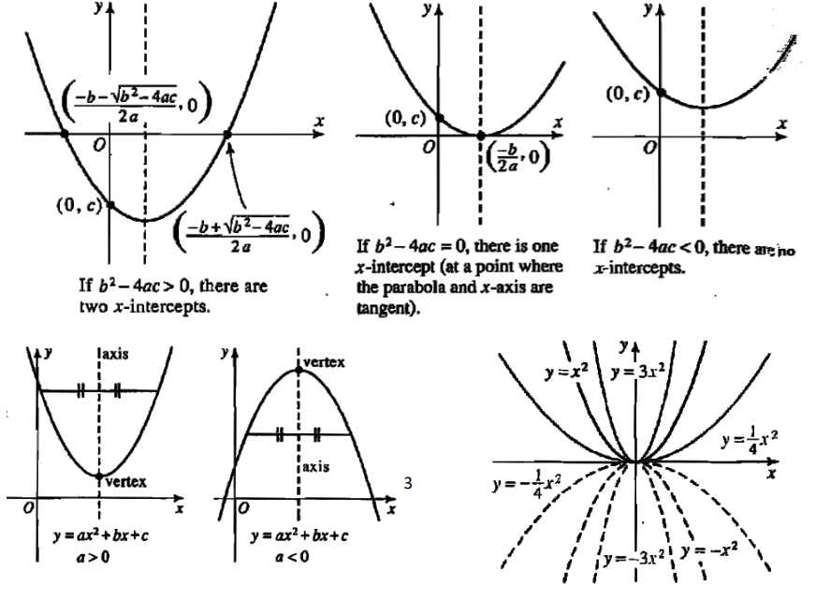

Statistics

- characteristics recorded about each individual are called variables.
  - categorical variable: variables that name categories and answers questions about how cases fall into those categories
  - quantitative variable: measure variable that answers questions about the quantity of what is measured
- tabular display:
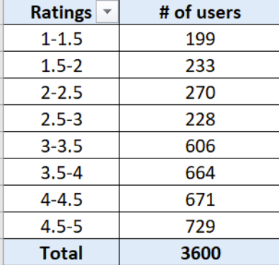
  - determine the number of nonoverlapping classes
  - approximate class width = $\frac{largest data value-smallest data value}{number of classes}$
  - determine the class limits
- dot plot: a simple graphical summary of data with a horizontal axis showing the range for the data and dots showing frequency
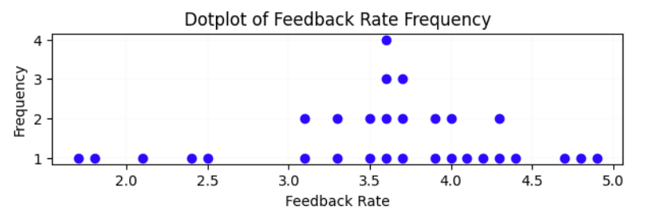
- histogram: a common graphical display of quantitative data, with ranges of values instead of values as the horizontal axis
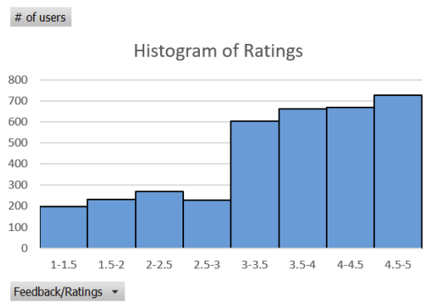
- stem-and-leaf plot: a graphical display used to show simultaneously the rank order and shape of a distribution of data
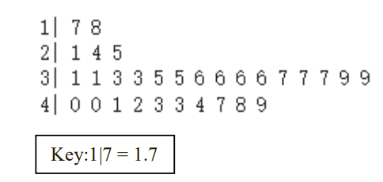
- boxplot: a graphic displaying the 5-number summary as a central box with whiskers that extend to the non-outlying data values.
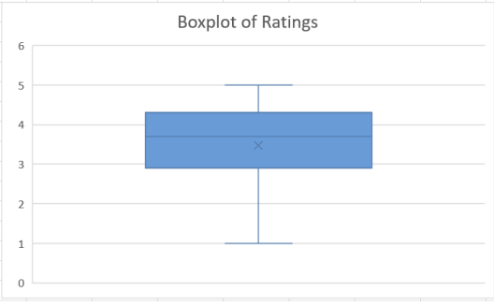
  - ends of the box located at the first and third quartile
  - segment drawn in the box at the location of the median.
  - using the interquartile range (a measure of variability that overcomes the dependency on extreme values) IQR = Q3 − Q1, limits are located at 1.5 (IQR) below Q1 and 1.5 (IQR) above Q3
  - whiskers: horizontal lines extending from each end of the box
    - drawn from the ends of the box to the smallest and largest values inside the limits
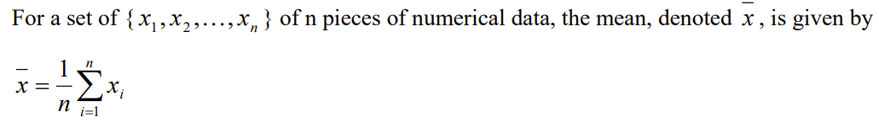
  - location of each outlier is shown with a small asterisk.

  - median: a measure of central location; the value in the middle when the data is arranged in ascending order
  - data set divided into four parts, with each part containing approximately one-fourth of the observations
    - just as the median divides a set of data into two equal parts, a quartile divides each part in half
  - range: the difference between the maximum and minimum values
- variance: a measure of variability that utilizes all the data
  - based on the difference between the value of each observation (x_{i}) and the mean
  - population variance: $σ^{2}=\frac{\sum{{\left(x_{i}-μ\right)}^{2}}}{N}$
  - sample variance: $s^{2}=\frac{\sum{{\left(x_{i}-\overline{x}\right)}^{2}}}{n-1}$
- standard deviation: the positive square root of the variance
- describing a distribution: 1. shape, 2. center, 3. spread
- quantitative data analysis (two variables):
  - response variable: variable of interest
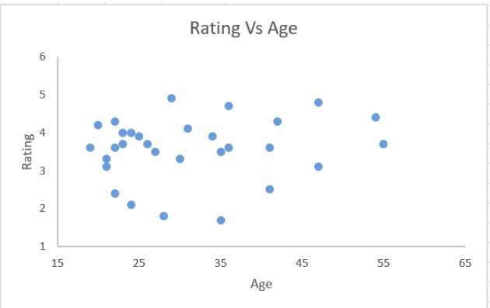
  - predictor/explanatory variable: the other variable
- scatterplot: shows the relationship between two quantitative variables measured on the same individuals.

  - overall pattern: 1. direction, 2. form, 3. strength, 4. outliers, 5. correlation: the direction and strength of the linear relationship between two quantitative variables
Drawings, Nets, and Other Models

- isometric drawing: a drawing of a figure from a corner view
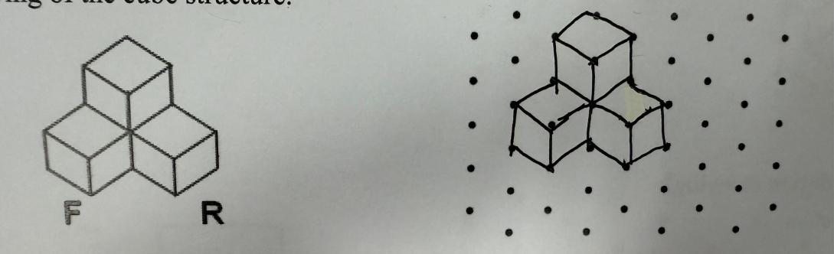
- orthographic drawing: a drawing showing a front, right, and top view
- foundation drawing: a drawing showing the layout of the structure and the dimensions of each part
- net: a two-dimensional shape that you can fold to form a 3D figure

Space Figures and Cross Sections
- polyhedron: a 3-dimensional figure where surfaces are polygons
- each polygon is a face of the polyhedron
- edge: a segment that is formed by the intersection of two faces
- vertex: a point where 3 or more edges intersect
- Euler’s Formula: the numbers of faces (F), vertices (V), and edges (E) of a polyhedron are related by F + V = E + 2
  - In two dimensions, Euler’s Formula reduces to F + V = E + 1
- cross section: the intersection of a solid and a plane
Surface Areas of Prisms and Cylinders
- prism: a polyhedron with exactly two congruent, parallel faces, called bases
  - other faces are lateral faces
  - prisms are named by the shape of its bases
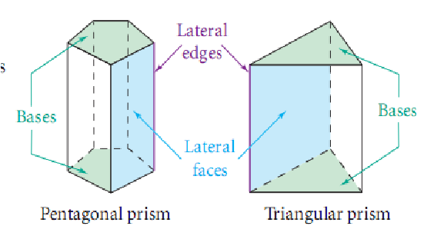
- lateral area of a prism: the sum of the areas of the lateral faces
- surface area is the sum of the lateral area and the area of the two bases.
- cylinder: two congruent parallel bases, which are circles
  - unrolling the curved face results in the lateral area
  - surface area is the sum of the lateral and the area of the two circular bases
- altitude of a prism (or a cylinder): a perpendicular segment that joins the planes of the bases
  - height h of the prism (or the cylinder) is the length of an altitude
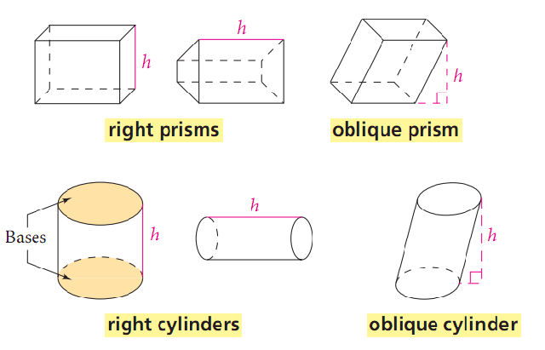
- right prism
  - lateral area: the product of the perimeter of the base and the height
  - L.A= ph
  - surface area: the sum of the lateral area and the areas of the bases
  - S.A.=LA+2B
- right cylinder
  - lateral area: the product of the circumference of the base and the height
  - L.A. = πdh or 2πrh
  - surface area: the sum of the lateral area and the areas of the two bases
  - S.A.=2B + L.A

Surface Areas of Pyramids and Cones
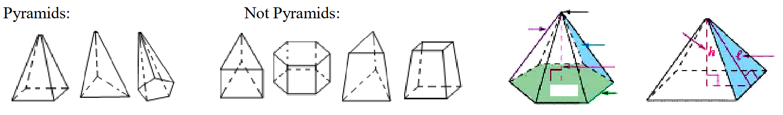
- pyramid: a polyhedron in which the base can be any polygon and other faces are triangles that meet at a common vertex
  - altitude: the perpendicular segment from the vertex to the plane of the base
  - the length of the altitude is the height h.
  - slant height (l): the length of the altitude of a lateral face of a pyramid
  - regular pyramid: a pyramid whose base is a regular polygon and whose lateral faces are congruent isosceles triangles
  - L.A.=0.5Pl S.A.=L.A.+2B
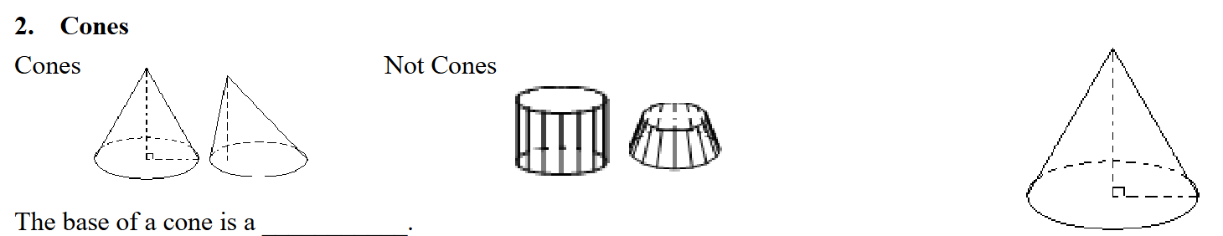
- cone: a polyhedron with a circular base that tapers to a single point
  - in a right cone, the altitude, height, and slant height l are the same as for a pyramid
- Lateral and surface areas of a cone: L.A.=πrl S.A.=L.A+2B

